Interactive Map:
The Link is http://vattsystems.com/Programlocator/Interactivemap.aspx
New Data: Cities-Aurora
Step 1 – Click the Cities Tab
Step 2 – Check the Checkbox Aurora
Output - Aurora data boundaries bind on the Interactive Map.
Screen shot:
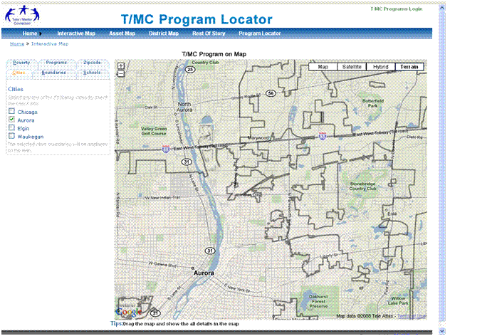

Interactive Map:
The Link is http://vattsystems.com/Programlocator/Interactivemap.aspx
New Data: Cities- Elgin
Step 1 – Click the Cities Tab
Step 2 – Check the Checkbox Elgin
Output - Elgin data boundaries bind on the Interactive Map.
Screen shot:
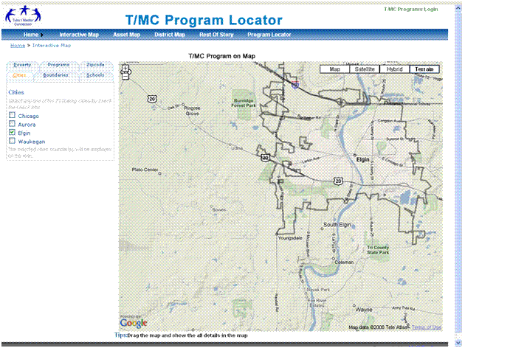

Interactive Map:
The Link is http://vattsystems.com/Programlocator/Interactivemap.aspx
New Data: Cities- Waukegan
Step 1 – Click the Cities Tab
Step 2 – Check the Checkbox Waukegan
Output - Waukegan data boundaries bind on the Interactive Map.
Screen shot:
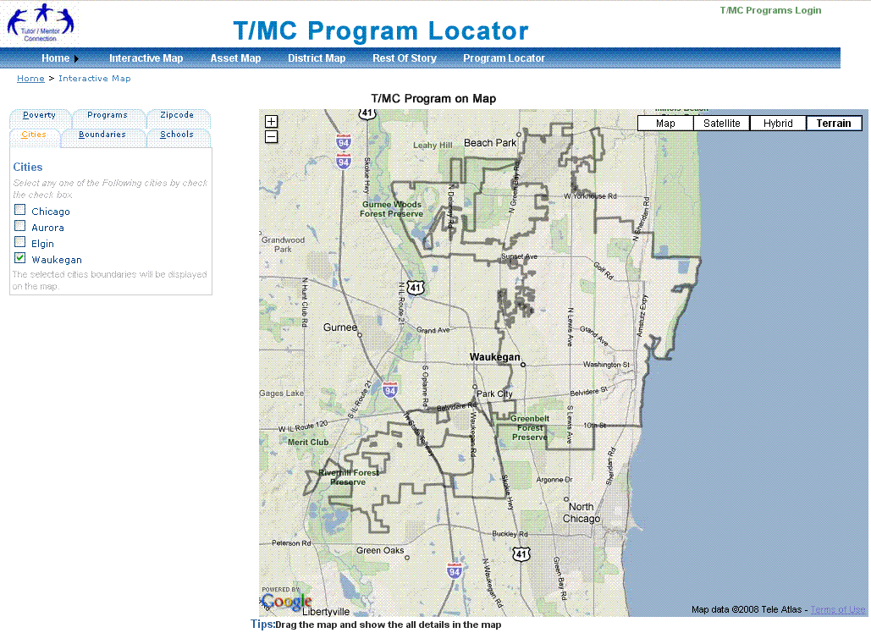

Asset Map:
The Link is http://vattsystems.com/Programlocator/AssetMapGalleries.aspx

Click the AssetMap menu it will go to the AssetMapGalleries Page.
Screen shot:
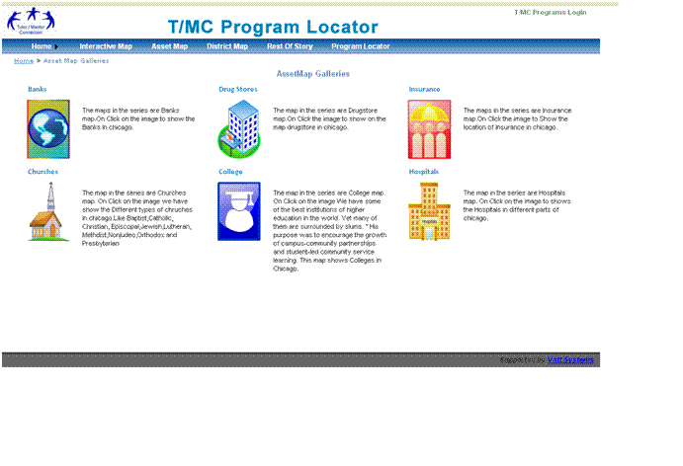

DrugStore:
The Link is http://vattsystems.com/Programlocator/AssetMapGalleries.aspx

New Data: Business – ChicagoPharmacies
Step 1 – Click the DrugStore Image, the page Redirect to the AssetMap page.
Step 2 – Business tab show the DrugStore.
Step 3 – Check the Checkbox ChicagoCVS
Step 4 - Output – ChicagoCVS Data boundaries bind on the Asset Map.
Step 5 – Click the Back To MapGalleries the page Redirect to AssetMapGalleris page.
Screen Shot:
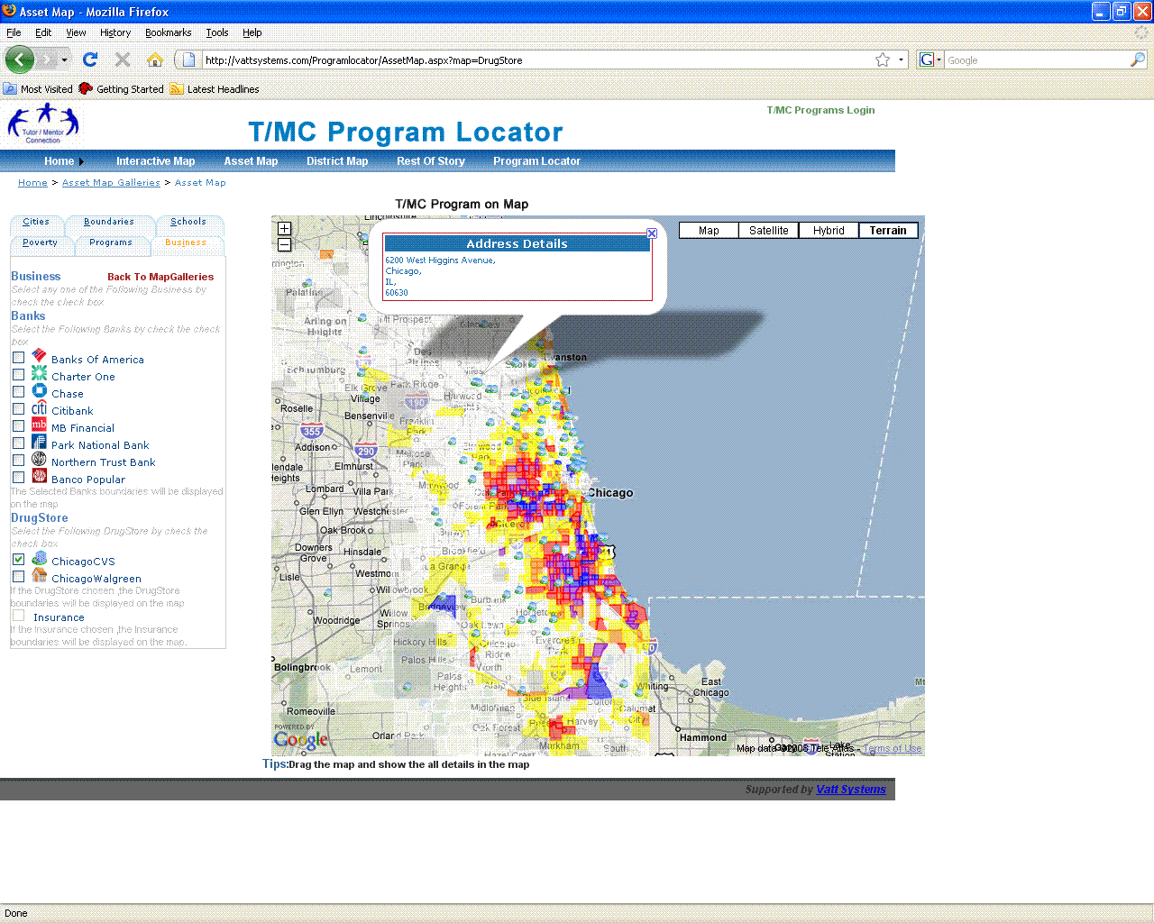

Banks:
New Data: Business – ChicagoBanks
Step 1 – Click the Bank Image, the page Redirect to the AssetMap page.
Step 2 – Business tab show the Banks.
Step 3 – Check the Checkbox Bank of America
Step 4 - Output – Bank of America Data boundaries bind on the Asset Map.
Step 5 – Click the Back To MapGalleries the page Redirect to AssetMapGalleris page.
Screen Shot:
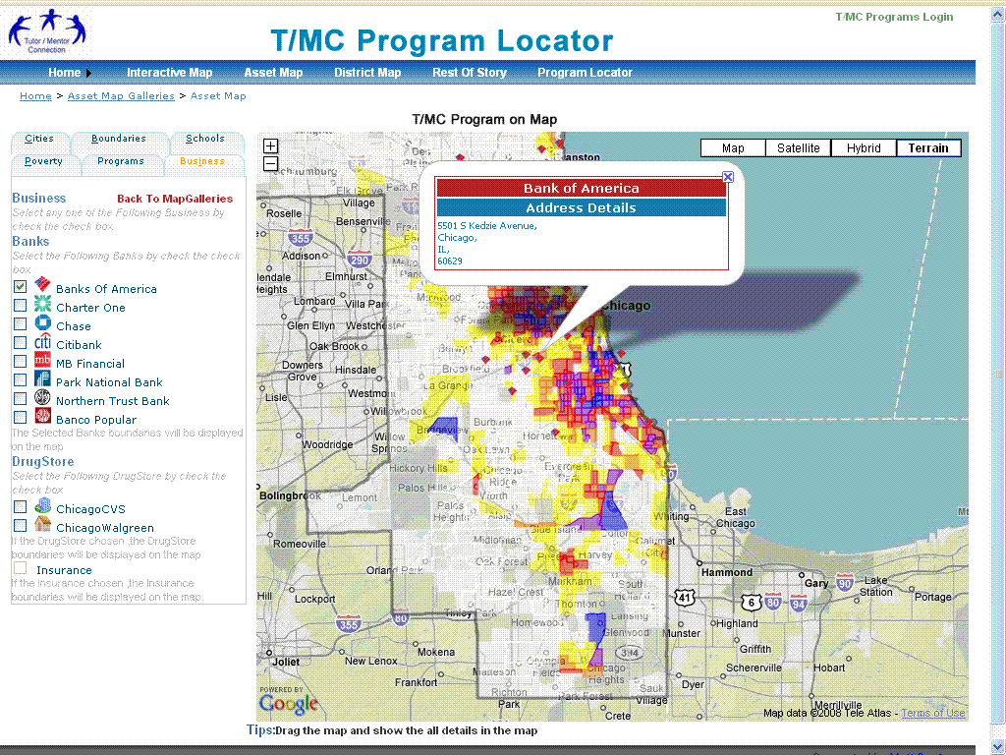

New Data: Business – ChicagoBanks
Step 1 - Check the Checkbox Charter One
Step 2 - Output – Charter One Data boundaries bind on the Asset Map.
Screen Shot:
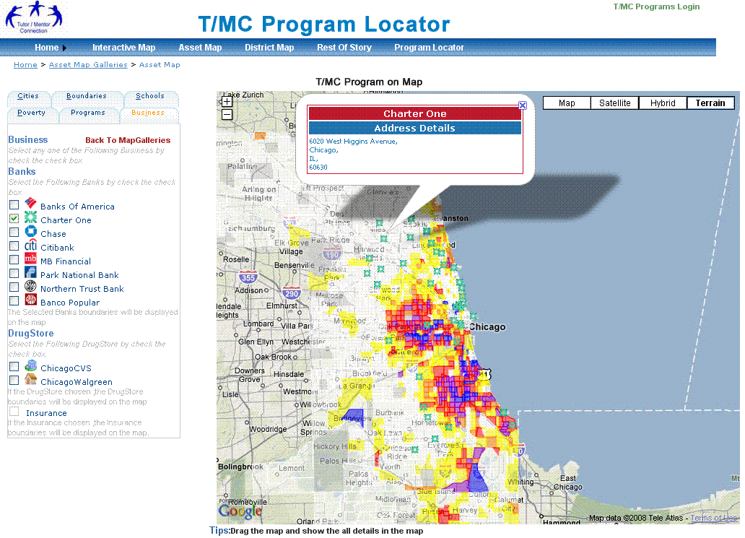

Colleges:
The Link is http://vattsystems.com/Programlocator/AssetMapGalleries.aspx
New Data: Business – IllinoisUniversities
Step 1 – Click the College Image, the page Redirect to the AssetMap page.
Step 2 – Colleges tab show the Colleges.
Step 3 – Check the Checkbox Colleges
Step 4 - Output – Colleges Data boundaries bind on the Asset Map.
Step 5 – Click the Back To MapGalleries the page Redirect to AssetMapGalleris page.
Screen Shot:
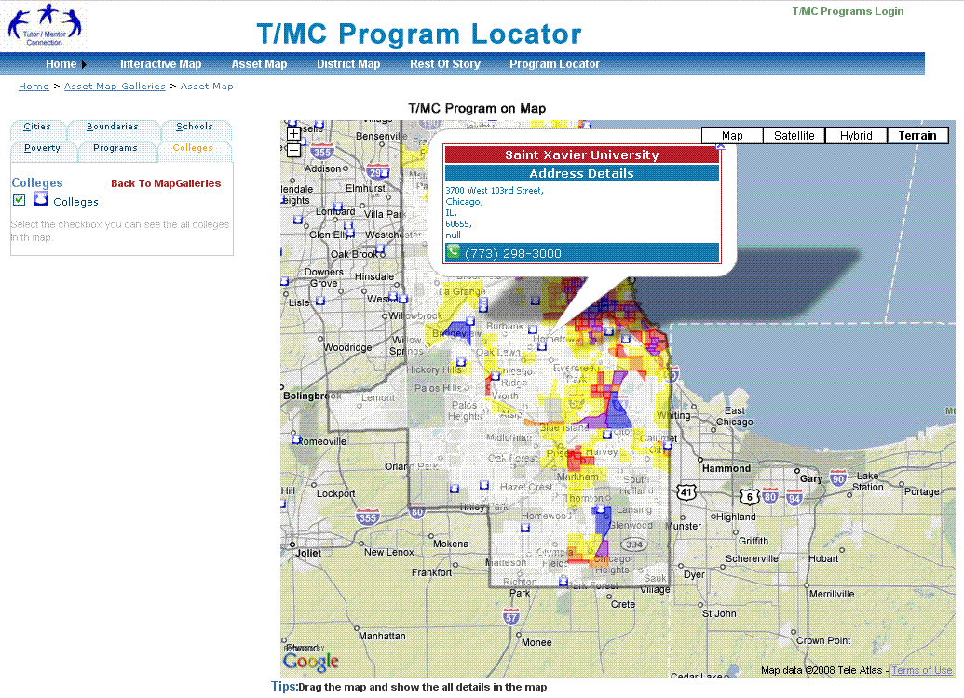

Hospitals:
The Link is http://vattsystems.com/Programlocator/AssetMapGalleries.aspx
New Data: Business – ChicagoHospitals
Step 1 – Click the Hospitals Image, the page Redirect to the AssetMap page.
Step 2 – Hospitals tab show the Hospitals.
Step 3 – Check the Checkbox Hospitals
Step 4 - Output – Hospitals Data boundaries bind on the Asset Map.
Step 5 – Click the Back To MapGalleries the page Redirect to AssetMapGalleris page.
Screen Shot:
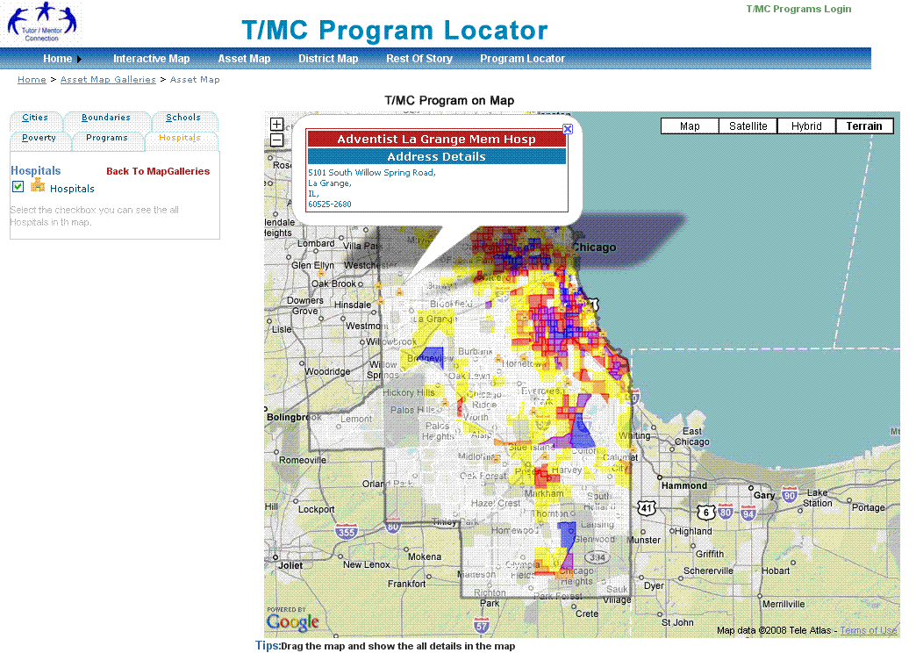

Interactive Map:
The Link is http://vattsystems.com/Programlocator/Interactivemap.aspx
New Data: Schools-Elementary (Additional datas)
Step 1 – Click the Schools Tab
Step 2 – Check the Checkbox Elementary
Output - Elementary data boundaries bind on the Interactive Map.
Screen shot:
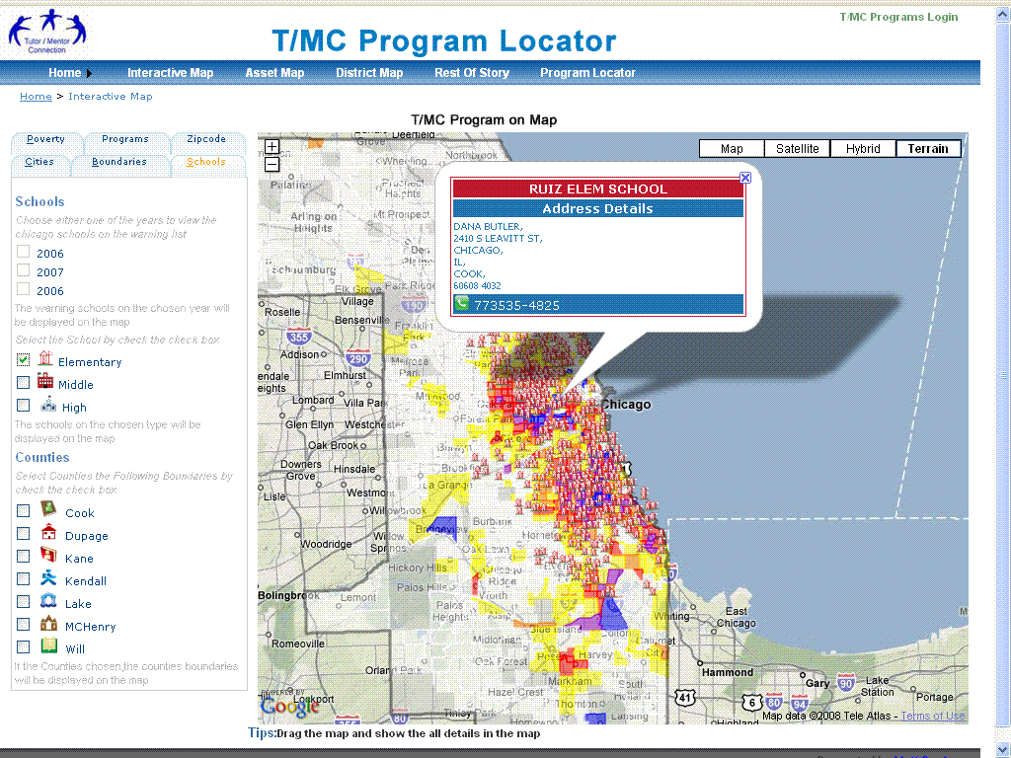

Interactive Map:
The Link is http://vattsystems.com/Programlocator/Interactivemap.aspx
New Data: Schools- Middle (Additional datas)
Step 1 – Click the Schools Tab
Step 2 – Check the Checkbox Middle
Output - Middle data boundaries bind on the Interactive Map.
Screen shot:
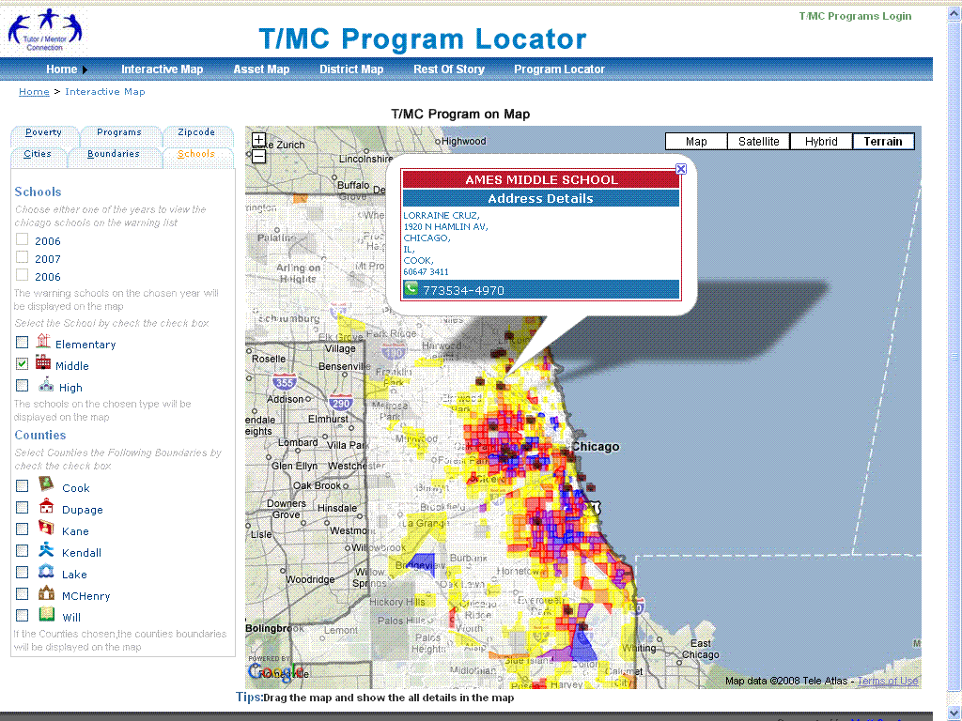

Interactive Map:
The Link is http://vattsystems.com/Programlocator/Interactivemap.aspx
New Data: Schools- High (Additional datas)
Step 1 – Click the Schools Tab
Step 2 – Check the Checkbox High
Output - High data boundaries bind on the Interactive Map.
Screen shot:
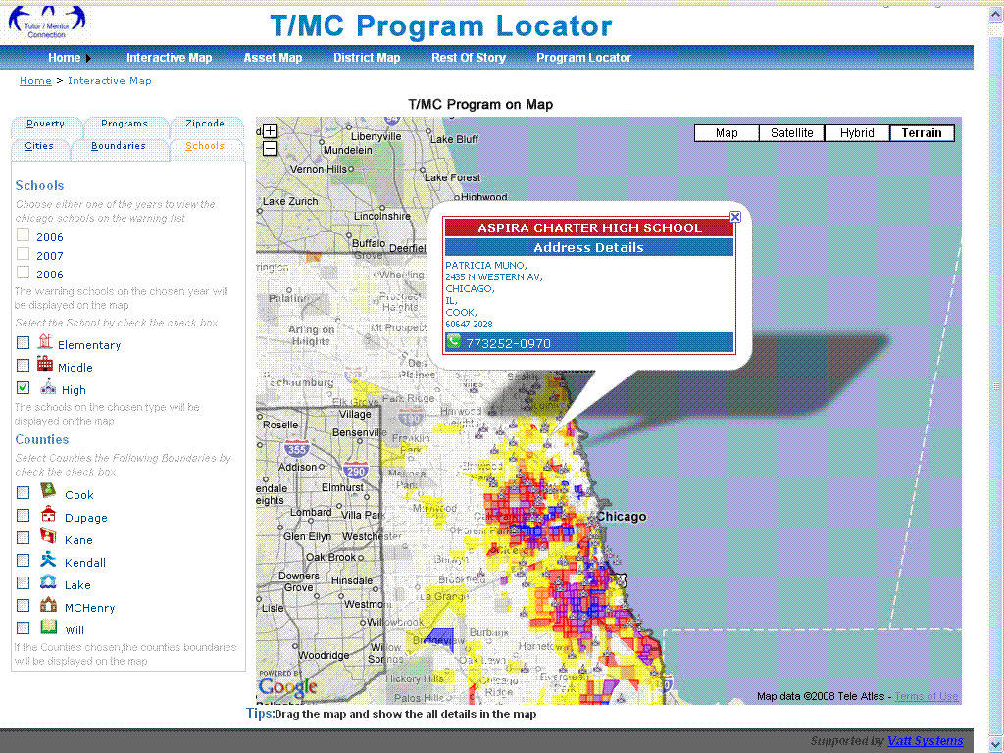

Interactive Map:
The Link is http://vattsystems.com/Programlocator/Interactivemap.aspx
New Data: Schools-Cook Counties
Step 1 – Click the Schools Tab
Step 2 – Check the Checkbox Cook
Output - Cook data boundaries bind on the Interactive Map.
Screen shot:
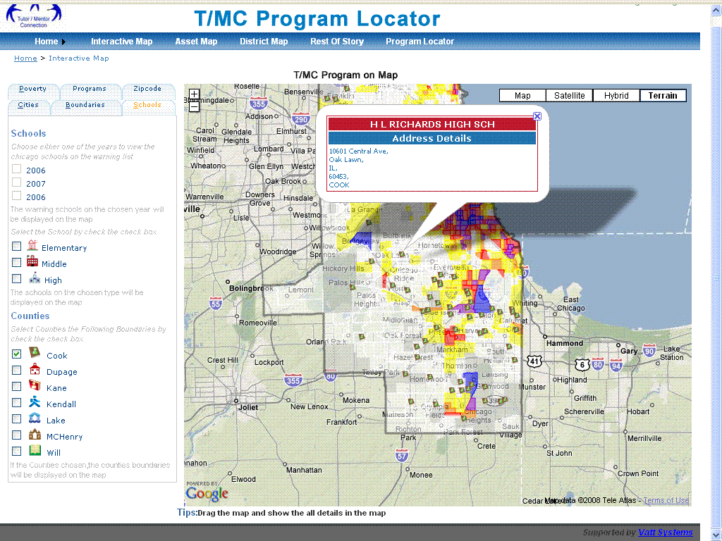

Interactive Map:
The Link is http://vattsystems.com/Programlocator/Interactivemap.aspx
New Data: Schools- Dupage Counties
Step 1 – Click the Schools Tab
Step 2 – Check the Checkbox Dupage
Output - Dupage data boundaries bind on the Interactive Map.
Screen shot:
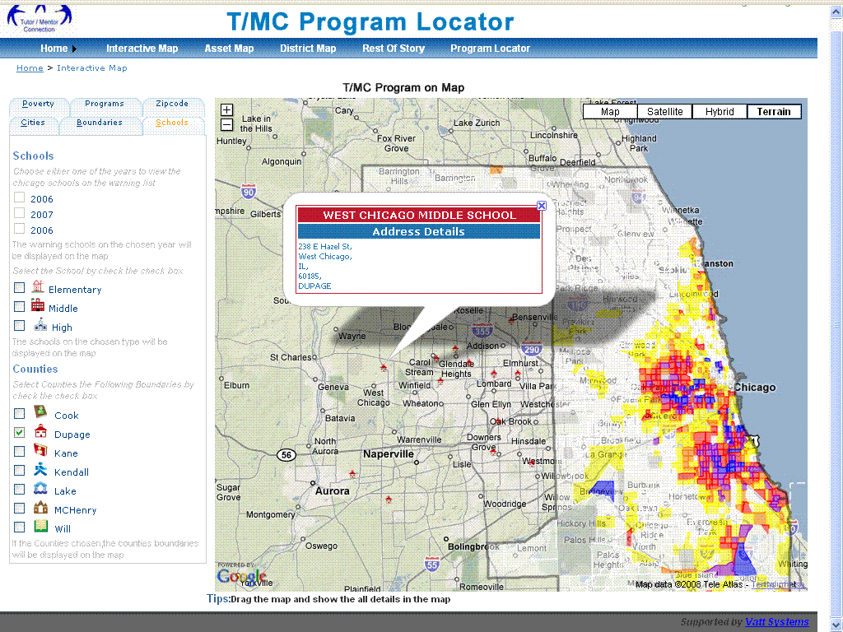

Interactive Map:
The Link is http://vattsystems.com/Programlocator/Interactivemap.aspx
New Data: Schools- Kane Counties
Step 1 – Click the Schools Tab
Step 2 – Check the Checkbox Kane
Output - Kane data boundaries bind on the Interactive Map.
Screen shot:
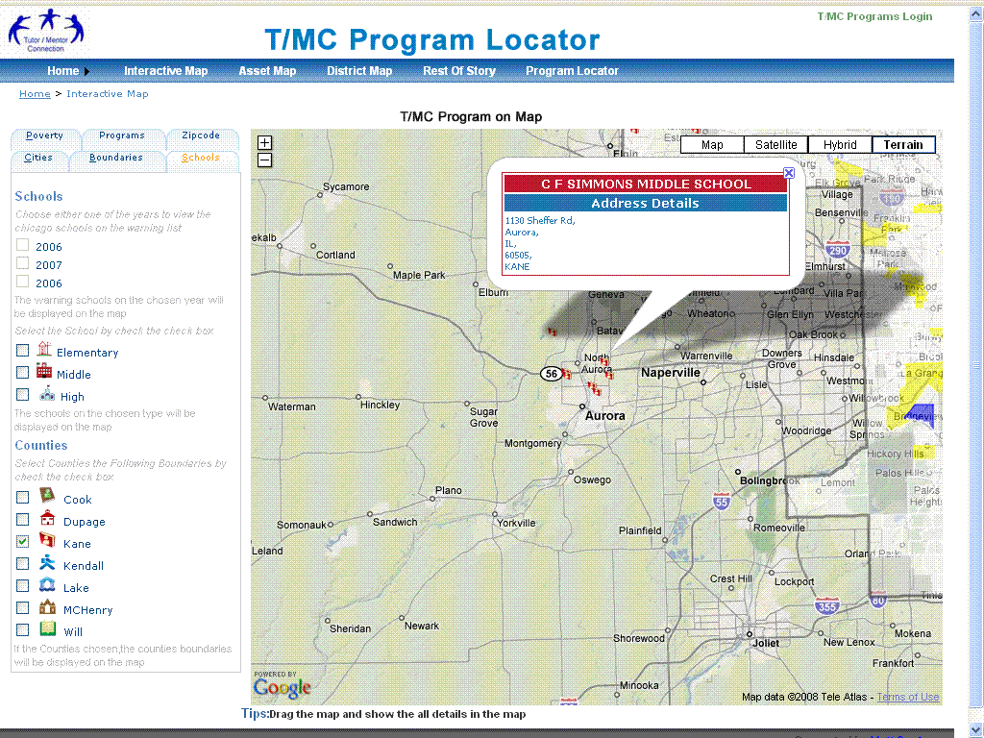

Interactive Map:
The Link is http://vattsystems.com/Programlocator/Interactivemap.aspx
New Data: Schools- Kendall Counties
Step 1 – Click the Schools Tab
Step 2 – Check the Checkbox Kendall
Output - Kendall data boundaries bind on the Interactive Map.
Screen shot:
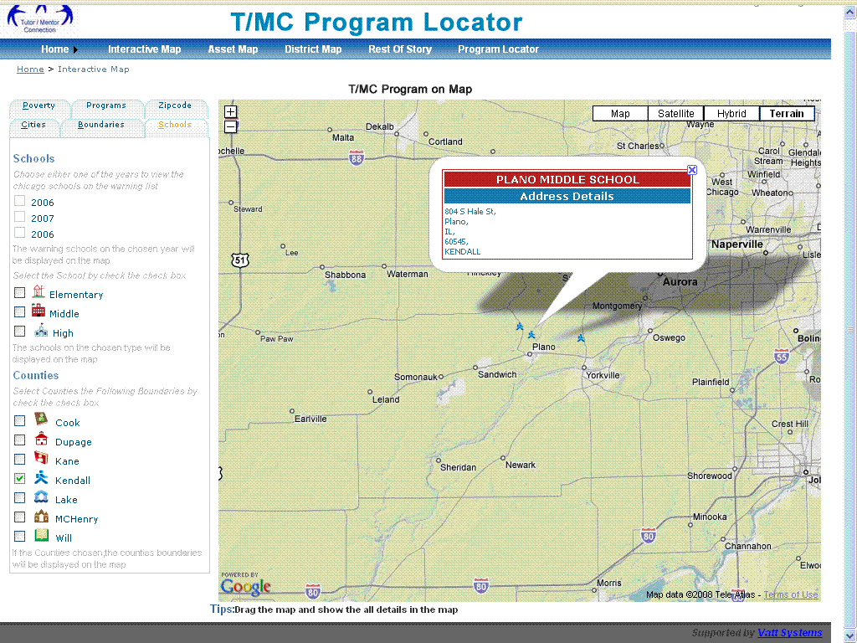

Interactive Map:
The Link is http://vattsystems.com/Programlocator/Interactivemap.aspx
New Data: Schools- Lake Counties
Step 1 – Click the Schools Tab
Step 2 – Check the Checkbox Lake
Output - Lake Data boundaries bind on the Interactive Map.
Screen shot:
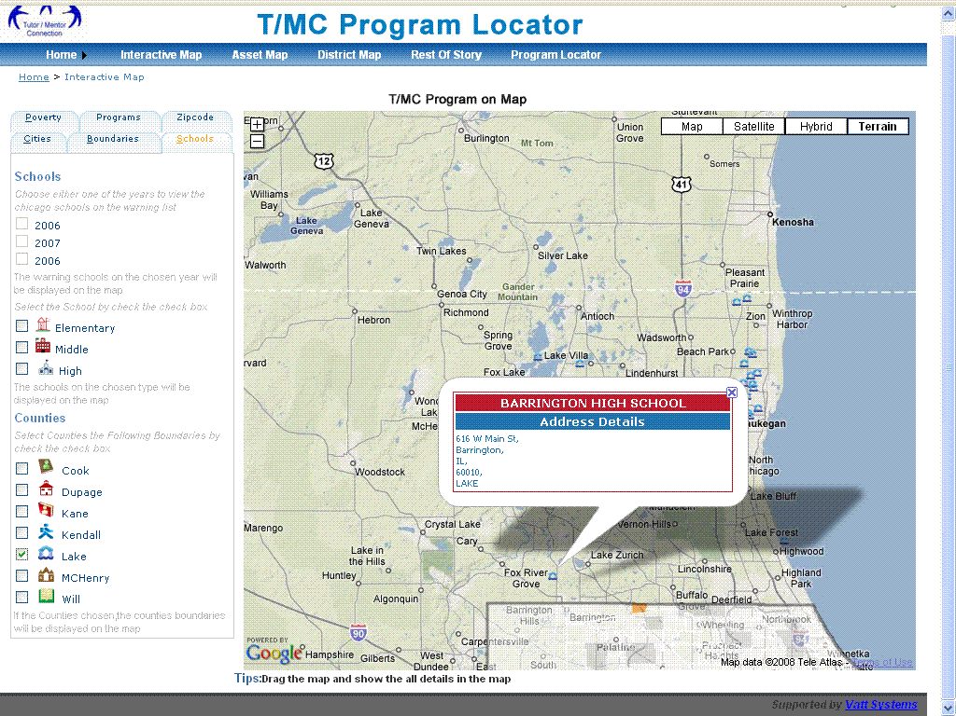

Interactive Map:
The Link is http://vattsystems.com/Programlocator/Interactivemap.aspx
New Data: Schools- MCHenry Counties
Step 1 – Click the Schools Tab
Step 2 – Check the Checkbox MCHenry
Output - MCHenry Data boundaries bind on the Interactive Map.
Screen shot:
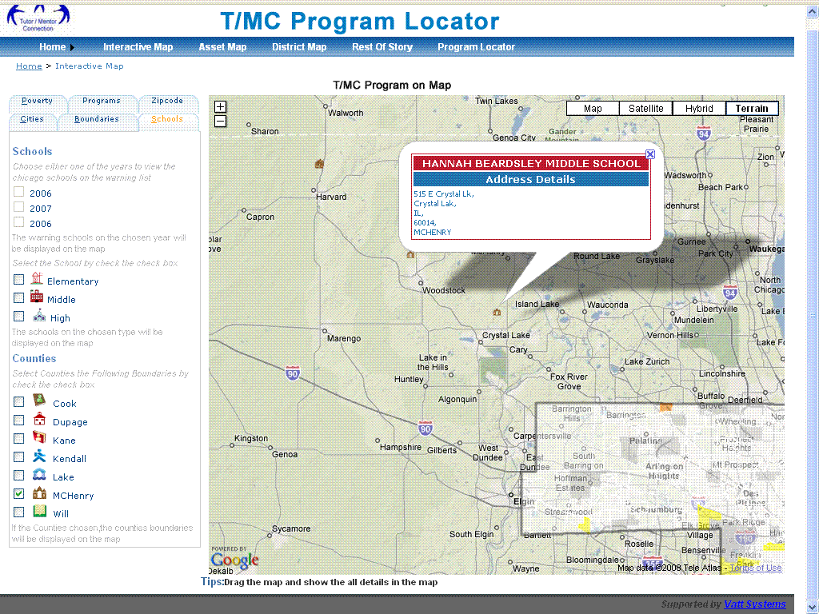

Interactive Map:
The Link is http://vattsystems.com/Programlocator/Interactivemap.aspx
New Data: Schools- Will Counties
Step 1 – Click the Schools Tab
Step 2 – Check the Checkbox Will
Output - Will Data boundaries bind on the Interactive Map.
Screen shot:
